slide 2: structure
slide 3: introduction to values
- intrinsic value - the flower has value in and of itself simply because it is a living organism, has no economic benefit, and is independent of any use
- instrumental value - the flower is valued based on fulfilling a role, specific utility, function (nectar source for bees => pollination), it is valued as a means to an end
- relational value - flower gains value from a shared responsibility, meaningful connection between nature and humans (a symbolic meaning)
- potential consequences (without flowers) - loss of insects (=> loss of pollination => loss of fruit and seeds) => loss of intervores => loss of birds and mammals

Slide 7
Consumer surplus is the extra value consumers receive when they buy a product for less than what they were willing to pay, often due to competition in the market.
the net rent otherwise known as producer surplus represents the benefit producers gain from selling a product or service that is higher than they’re willing to accept.

Slide 8
The net rent + consumer surplus = total economic value

Slide 9
In the second graph the supply is vertical because ecosystem services cannot be increased or decreased by actions of the economic system.To estimate the value per unit area of each ecosystem service for each ecosystem type 3 different methods were used: the first was combining the consumer and producer surplus; the second - the net rent or producer surplus alone and the third was the price times quantity as a proxy for the economic value of the service.

Slide 10
There are quite a few limitations when it comes to the calculations since they are mostly theoretical. These limitations come about because in the analysis, the scientists synthesized previous studies based on a wide variety of methods which come with their own restrictions. As I mentioned, some of the calculations are theoretical since in the study it was tried to estimate the total value of ecological services, regardless of whether they are currently marketed. And some services are not currently marketed because there is very little relation between the value of services and observable current spending behaviour in many cases. In simpler terms - a large part of the contributions to human welfare by ecosystem services are of a purely public goods nature. They accrue directly to humans without passing through the money economy at all. In many cases people are not even aware of them, for eg. clean air and water or climate regulation and countless others. The estimate of the then current margin of what the services are worth annually is written down in the table as 33 trillion US$, however the range is estimated to be between 16-54 trillion US$. Although this number has most likely grown quite a bit since the study was conducted because as natural capital and ecosystem services become more stressed and more “scarce” their value is expected to increase. Furthermore if significant, irreversible thresholds are passed for irreplaceable ecosystem services, their value may quickly jump to infinity.

Slide 11
Disturbance regulation - (refers to the benefits provided by ecosystems that help moderate natural phenomena, maintaining ecological balance by regulating climate, water and mitigating extremes) capacitance, damping and integrity of ecosystem response to environmental fluctuation eg. Storm protection, flood control, drought recovery and other habitat response to environmental variability mainly control les by vegetation structure

Slide 12
Nutrient cycling - storage, internal cycling, processing and acquisition of nutrients eg. Nitrogen fixation, N, P and other elemental or nutrient cycles

Slide 13
Biological control - (refers to the decline in pest density as a result of the presence of natural enemies) trophic-dynamic regulation of populations eg. Keystone predator control of prey species, reduction of herbivory by top predators

Slide 14
Genetic resources - sources of unique biological materials and products (also refer to the hereditary traits and genetic material available in microorganisms) eg. Medicine, products for material science, genes for resistance to plant pathogens and crop pests, ornamental species (pets and horticultural varieties of plants)

Slide 15
Refugia/habitat - habitat for resident and transient populations eg. Nurseries, habitat for migratory species, regional habitats for locally harvested species, or overwintering grounds.

slide: forest issues and threats
- deforestation - forests are important for global climate, species habitat, food supply
reasons for deforestation:
- agribusiness - for plantations and livestock, Indonesia - palm oil (cosmetics, food)
- mining - coal,gold,copper, etc. - demands clearing of forests, disrupts wa =ter systems in that area
- other: illegal logging, building
- pollution - acidification (sulfur dioxide - can alter the pH of soil), eutrophication (nitrogen - changes soil chemistry and nutrients availability)
- drought = prolonged periods of dry weather, drought pressure has intensified in recent years => increased tree mortality, reduced biodiversity, bigger vulnerability to diseases and pests
drought pressure = strain placed on plants/ecosystems due to evaporated water

The two papers are 21 years apart and share a goal: making nature’s contributions count in decisions. They differ in how they define and express those contributions. Costanza et al. estimate the value in money. Díaz et al. argue for plural ways of describing value and for including more kinds of knowledge.

Examples and comparison of the papers:
In 1997 it is a priced service of about US$117 billion a year, In 2018 the IPBES pollinator assessment, which Díaz et al. cite, records indigenous and local descriptions of it as a practice of care: forests with nesting places, totemic relationships with obligations in both directions, and governance that depends on bees and butterflies being present.
Similarity
Both cover broadly the same ground (food, water, regulation, recreation), both acknowledge that their categories overlap, and both want nature to carry more weight in decision-making.
Difference
Money versus plural description of value, nature as provider versus relationships of reciprocity, and benefits only versus benefits and harms
Reasons
Ecology and economics dominated ecosystem services research after the Millennium Ecosystem Assessment.
Social sciences, local practitioners and indigenous peoples were largely left out.
Concerns about commodification and social equity grew.
The forests
1997: forests are valued per hectare per year: about $2,007 for tropical and $302 for temperate/boreal, and about 4.7 trillion for all forests. The authors already note that forests also hold soil and moisture and create microclimates, mostly in non-marketed ways.

2018: forests appear as providers of recreation and inspiration and as sites of sacred trees and landscapes, with culture running through all their contributions.

Ecosystem Services and the economy
Much of their value is outside markets and so outside GNP. Example: if forest management adds $50 of timber and $70 of non-market value, only the $50 passes through markets.
Costanza et al. estimate about US$33 trillion a year(ranging from US$16–54 trillion), about 1.8 times global GNP at the time, and describe it as a minimum.
slide No 4.
key point (the question has changed from “what is nature worth?” to “what does nature give people and who decides it?”)
Brief mention of Biosphere II.
slide No 5.
The different perspectives of each paper on seeing nature.
slide No 6.
Are the papers contrary to one another?
The differences of the papers as well as similarities.
Extra info
Distinctions between services and contributions
- ES (ecosystem services) literature tends to embrace discrete and rigid categorizations, and thus fluid connections across NCP (nature’s contributions to people) categories and groups may be novel
- The plurality and flexibility claimed by the NCP concept to engage the social sciences and humanities seems to have made notable progress within ES research and practice
- NCP could accommodate a variety of value types beyond instrumental (and intrinsic) values, creating spaces for exploring relational values of nature which have been scarcely covered in ES literature
- Acknowledging that ES presents several limitations that may diminish its ability for communicating across disciplinary and societal worlds, NCP could represent a powerful communication tool to facilitate dialogue and understanding between a wide range of stakeholders in order to co-produce knowledge for people and nature relations where the ES framework has been limited in acting as common language or a ‘boundary object’
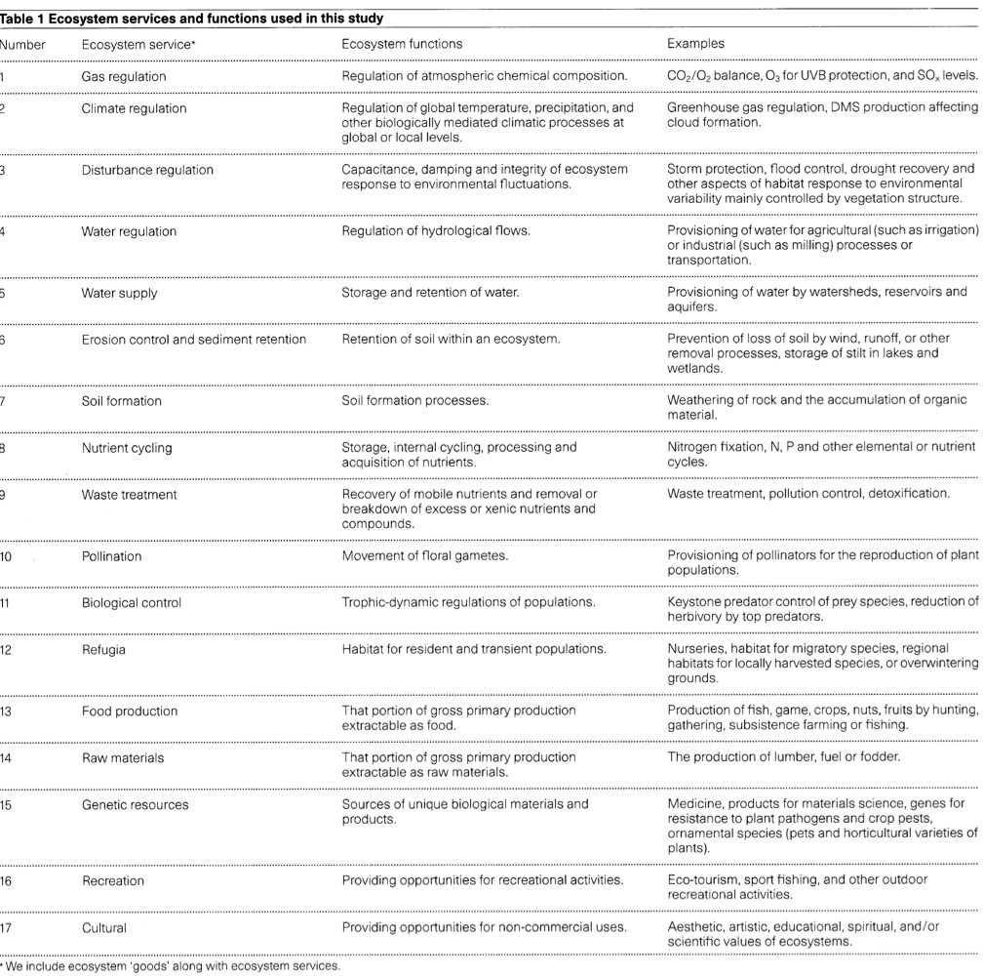
https://github.com/zhanxdani/nature-value-explorer

